**Plant Irrigation by Water Sprinkler Robot**

Mr. Sharanappa A.G1, Mr. Himanshu2, Mr. Ashish3, Mr. Abhishek YN4

1Asst. Professor, Mechanical Engineering, KNS Institute of Technology, Bangalore, India

234U.G. Students, Department of Mechanical Engineering, KNS Institute of Technology Bangalore, India,

[js.himanshu.sen2@gmail.com](mailto:js.himanshu.sen2@gmail.com), [ashishpatila57@gmail.com](mailto:ashishpatila57@gmail.com), [abhishekyn67@gmail.com](mailto:abhishekyn67@gmail.com)

Abstract - Indian agriculture is diverse ranging from impoverished farm villages to developed farms utilizing modern agricultural technologies. Facility agriculture area in China is expanding and is leading the world. However, its ecosystem control technology is still immature, with low level of intelligence. Promoting application of modern information technology in agriculture will solve a series of problems facing by farmers. Lack of exact information and communication leads to the loss in production. Our paper is designed to overcome these problems. This system provides an intelligent monitoring platform framework and system structure for facility agriculture ecosystem based on IOT. This will be a catalystfor the transition from traditional farming to modern farming. This also provides opportunity for creating new technology and service development in IOT (internet of things) farming application. The Internet of Things makes everything connected. Over 50years since independence, India has made immense progress towards food productivity. The Indian population has tripled, but food grain production more than quadrupled there has thus been a substantial increase in available food grain per ca-pita. Modern agriculture practices have a great promise for the economic development of a nation. So we have brought-in an innovative project for the welfare of farmers and also for the farms. There are no day or night restrictions. This is helpful at any time.

**Key Words:** IoT, Smart Agriculture, Humidity,

Temperature, Soil Moisture, Arduino.

1. INTRODUCTION

Smart Agriculture developing model is a real time monitoring system It monitor the soil properties like temperature, humidity soil moisture PH etc. It is possible to control many operations of the field remotely from anywhere, anytime by IOT. It offers a futuristic way of life in which an individual gets to control his electronic devices using a smart phone, it also offers an efficient use of energy. It applied in all areas of industry, including smart agriculture, smart parking, smart building environmental monitoring, healthcare transportation and many more.

1. LITERATURE SURVEY

In the existing system of agriculture, the crops are being monitored with the help of Arduino boards and GSM technology where in Arduino boards acts as a microcontroller but not as a server. Hence in order to overcome all these features Arduino Nano boards or renesas microcontrollers are being included with the NodeMCU which a latest version is and also acts both as a microcontroller as well as server. Main feature of this methodology is its cheap cost for installation and multiple advantages. Here one can access as well as control the agriculture system in laptop, cell phone or a computer.

1. PROBLEM STATEMENT

The proposed paper aims to supply water when farm is dry without human presence and avoiding water wastage in irrigation process. Also monitor the soil parameters like temperature, humidity and soil moisture level. It will also be possible to control various operations of the field remotely from anywhere, anytime by mobile as well as web application.

This gives signals to the mobile phone whether to send water (that is when farm is dry) to the field or not.

1. PROPOSED SYSTEM

The smart agriculture model main aim to avoid water wastage in the irrigation process. It is low cost and efficient system Is shown below.

It includes NodeMCU, Arduino Nano, sensors like soil moisture and Dht11, Ssolenoid valves, relays.

NodeMCU: NodeMCU is an open source IoT platform. it includes firmware which runs on the ESP8266 Wi-Fi SoC from Expressive Systems, and hardware which is based on the ESP-12 module.

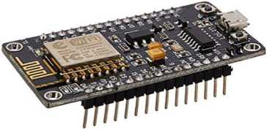

Fig. 1: NodeMCU

The term "NodeMCU" by default refers to the firmware rather than the dev kits. The firmware uses the Lua scripting language. The programming code is being written for ESP8266 Wi-Fi chip using Arduino IDE, for which installation of ESP8266 library is required. We designed to make

working with this chip super easy and a lot of fun. We took a certified module with an onboard antenna, and plenty of pins, and soldered it onto our designed breakout PCBs. While this chip has been very popular, its also been very difficult to use. Most of the low-cost modules.

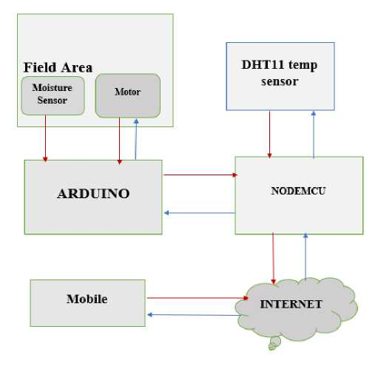

Fig. 2: Block Diagram of Smart Agriculture Model

Arduino Nano: The Arduino Nano is a small, complete, and breadboard-friendly board based on the ATmega328 or ATmega168. It has more or less the same functionality of the Arduino Duemilanove, but in a different package. The Power­down mode saves the register contents but freezes the Oscillator, disabling all other chip functions until the next interrupt or hardware reset.

In Power-save mode, the asynchronous timer contains to run, allowing the user to maintain a timer base while the rest of the device is sleeping. The ADC Noise Reduction mode stops the CPU and all I/O modules except asynchronous timer and ADC to minimize switching noise during ADC conversions. In Standby mode, the crystal/resonator oscillator is running while the rest of the device is sleeping. This allows very fast start-up combined with low power consumption. In Extended Standby mode, both the main oscillator and the asynchronous timer continue to run.

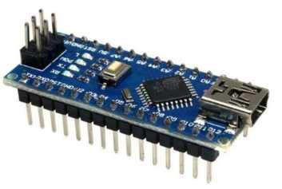

Fig. 3: Arduino Nano

Relay Module: A relay is an electrically operated switch. Many relays use an electromagnet to mechanically operate a switch, but other operating principles are also used, such as solid-state relays. Relays are used where it is necessary to control a circuit by a separate low-power signal, or where several circuits must be controlled by one signal. The first relays were used in long distance telegraph circuits as amplifiers: they repeated the signal coming in from one circuit and re-transmitted it on another circuit.

Moisture Sensor: A simple soil moisture sensor for gardeners. Soil moisture sensors measure the volumetric water content in soil. Since the direct gravimetric measurement of free soil moisture requires removing, drying, and weighting of a sample, soil moisture sensors measure the volumetric water content indirectly by using some other property of the soil, such as electrical resistance, dielectric constant, or interaction with neutrons, as a proxy for the moisture content. The relation between the measured property and soil moisture must be calibrated and may vary depending on environmental factors such as soil type, temperature, or electric conductivity. Reflected microwave radiation is affected by the soil moisture and is used for remote sensing in hydrology and agriculture. Portable probe instruments can be used by farmers or gardeners.

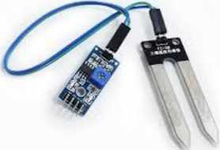

Fig. 4: Moisture Sensor

Operation: There are many valve design variations. Ordinary valves can have many ports and fluid paths. A 2­way valve, for example, has 2 ports; if the valve is open, then the two ports are connected and fluid may flow between the ports; if the valve is closed, then ports are isolated. If the valve is open when the solenoid is not energized, then the valve is termed normally open. Similarly, if the valve is closed when the solenoid is not energized, then the valve is termed normally closed. There are also 3-way and more complicated designs. A 3-way valve has 3 ports; it connects one port to either of the two other ports typically a supply port and an exhaust.

1. EXPERIMENTAL RESULTS

In this project we can control the motor in the field based on humidity, temperature and moisture level. The Moisture level of soil is measure or sensed by the sensors. These values are converted into digital form and applied to Arduino Nano. If the moisture levels of soil are dropped to a certain level the motor is turned on automatically without human interaction.

We use single motor for two different farms. The Solenoid valve controls the flow of water by measuring the moisture levels of their soil. For two farms we use two moisture sensors, those are connected to microcontroller and sends moisture levels continuously.

As shown in the below figure 7 we have two modes in this system, automatic and manual. In automatic the motor can control automatically based on sensor data. In manual mode we can control the motors.

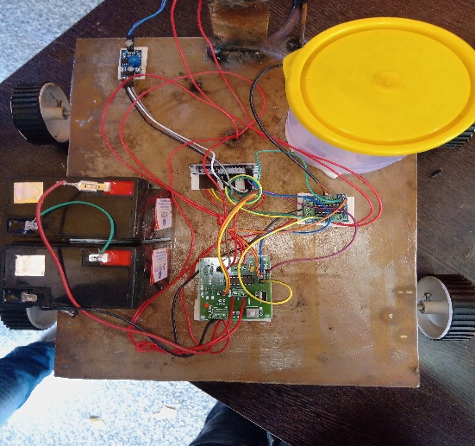

**Fig. 5:** Experimental Setup

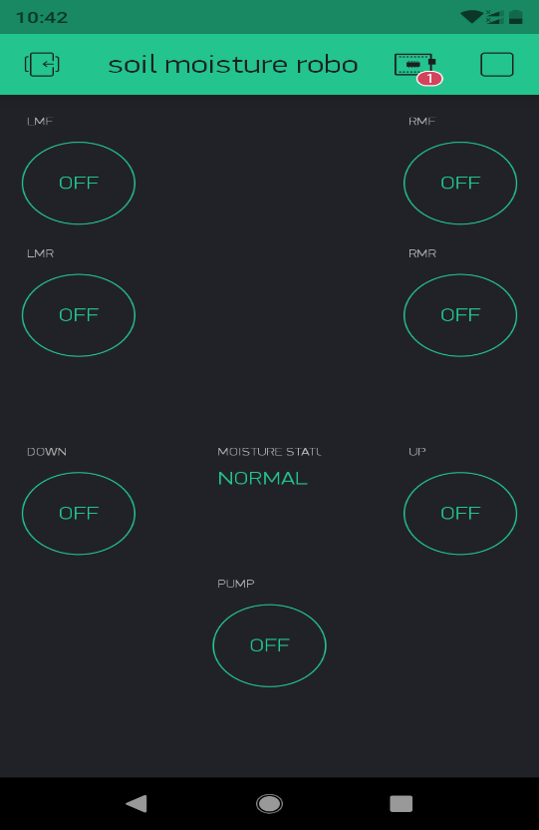

**Fig. 6:** Screenshot of blynk app

1. CONCLUSION

The smart agriculture using IOT has been experimentally proven to work satisfactorily by monitoring the values of humidity and temperature successfully. Through the internet control the motor in the field. It also stores the sensor parameters in the timely manner. This will help the user to analyze the conditions of various parameters in the field anytime anywhere. Then control or maintain the parameters of field properly. Finally, we conclude that automatic irrigation system is more efficient than scheduled irrigation process.

**7. REFERENCES**

1. Sirsath N. S, Dhole P. S, Mohire N. P, Naik S. C &Ratnaparkhi N.S, “SMART AGRICULTURE USING Cloud Network and Mobile Devices”.
2. Amardeo C, Sarma. I G. Identities in the Future Internet of
3. Things[J]. Wireless Pers Commun, Vol. (49): 353- 363 2009.
4. Kim Y,Evans R G,Iversen W M. Remote sensing and control of an irrigation system using a distributed wireless sensor network. IEEE Transactions on Instrumentation and Measurement 2008.
5. Wang N, Zhang N P, Wang M H. Wireless sensors in agriculture and food industry-Recent development and future perspective[J]. Computers and Electronics in Agriculture, 2006.
6. Chan, M., Campo, E., Esteve, D., Fourniols, J.Y., “Smart homes-current features and future perspectives,” Maturitas, vol. 64, issue 2, pp. 90-97, 2009.
7. Das, S.R., Chita, S., Peterson, N., Shirazi, B.A., Bhadkamkar,
8. M., “Home automation and security for mobile devices,” IEEE PERCOM Workshops, pp. 141- 146, 2011.
9. S.D.T. Kelly, N.K. Suryadevara, S.C. Mukhopadhyay, “Towards the Implementation of IoT for Environmental Condition Monitoring in Homes”, IEEE, Vol. 13, pp. 3846- 3853, 2013.
10. Nicholas D., Darrell B., Somsak S., “Home Automation using Cloud Network and Mobile Devices”, IEEE Southeastcon 2012, Proceedings of IEEE.
11. Liu Hang, Liao Guiping, Yang Fan. Application of wireless sensor network in agriculture producing [J]. Agricultural Network Information, 2008.
12. Lin Yuanguai. An Intelligent Monitoring System for Agriculture Based on ZigBee Wireless Sensor Network Journal. Advanced Materials Research, Manufacturing Science and Technology, Vols.383〜399:4358〜4364, 2011.
13. Zhang Chunhong. The Internet of Things Technology and Applications [M]. Beijing: Posts & Telecom press, 2011.
14. Yang Guang, Geng Guining, Du Jing, Liu Zhaohui, Han He, “Security threats and measures for the Internet of Things”, Qinghua Daxue Xuebao/Journal of Tsinghua University, Vol. 51, 2011.
15. Kun Gao, Qin Wang, Lifeng Xi, "Controlling Moving Object in the Internet of Things.